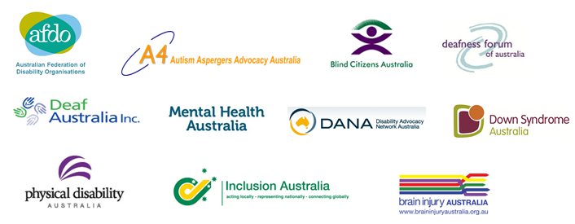
Disability Australia Election Platform for 2016

Disability Australia calls on all political parties to support our Election Platform to address the chronic disadvantage of people with disability.

We ask all major political parties to maintain a long-term commitment to the following five objectives:

- Support the NDIS to be rolled out by 2019, so that 460,000 Australians with disability can live an ordinary life

- Support the success of the NDIS by resourcing the National Disability Strategy

- Improve employment of people with disability by influencing public sector recruitment, procurement and reorientating the DES system

- Address abuse and neglect through transitioning people with disability from institutions to the community and providing the safeguard of a strong independent advocacy sector

- Fund specialist people with disability organisations that are experts of their own communities

Details of our platform can be found below. All major political parties are being approached with the same request.

Disability Australia Election Platform

- Support the NDIS to be rolled out by 2019, so that 460,000 Australians with disability can live an ordinary life

The NDIS is the greatest social reform of our time. As such, it is critical that we get it right. Disability Australia calls for:

- Roll out of a nationally consistent Scheme by 2019 across Australia so that people with disability and their families can live an ordinary life just like any other Australian
- Genuine commitment to program improvement, drawing on the expertise of specialist people with disability organisations to address programmatic issues as they arise and ensure that the Scheme meets its principles to improve social and economic participation
- Invest in community capacity building through LAC and ILC programs to open up opportunities for people with disability (including those not funded by the Scheme) to genuinely participate in community life and access mainstream services
- Support people with disability in the NDIS by strengthening independent advocacy

- Support the success of the NDIS by resourcing the National Disability Strategy (NDS)

While the NDIS seeks to address individual barriers to participation, the National Disability Strategy is critical to address the systemic changes needed to enable an ordinary life: accessible public transport, inclusive education, universal design and genuine participation in the everyday life of communities across Australia.

The NDIS and NDS must work hand in hand, however to date the Strategy lies dormant and under-resourced with no accountability. Decades of segregation of people with disability cannot be addressed purely by the NDIS. Disability Australia calls for:

- Dedicated year on year funding to implement the intent of the Strategy in conjunction with specialist people with disability organisations to ensure genuine change on the ground
- Effective measurement strategies co-designed with people with disability to ensure tangible progress is made and measured over time

- Improve employment of people with disability by influencing public sector recruitment, procurement and reorientating the DES system

Disability Australia calls for:

- Introduction of measurable targets for employment of people with disability in the Australian Public Service and better use of levers, such as government procurement practices, to drive attitudinal and practice change in the public, private and not for profit sector
- Improve mainstream education of people with disability to address long-term chronic disempowerment
- Significant reorientation of the current disability employment funding model to be consistent with the principles of the NDIS and build the capacity of jobseekers with disability and support businesses to recruit and retain employees with disability

4. Address abuse and neglect through transitioning people with disability from institutions to the community and providing the safeguard of a strong independent advocacy sector

The most effective strategies in bringing abuse to light include well resourced representation and advocacy support to enable people with disability to speak up as well as genuine inclusion within mainstream communities where abusive practices are less likely to go unnoticed.

Disability Australia calls for:

- Continued, stable funding of independent advocacy organisations to assist people with disability to blow the whistle on abuse and minimise restrictive practices
- Bi-partisan commitment and leadership to draw a ‘line in the sand’ on the funding of segregated, closed system models (residential institutions and Australian Disability Enterprises) in favour of models that work with individuals with disability to transition to and/or commence a mainstream, ordinary adult life

- Fund specialist people with disability organisations that are experts of their own communities

Disability is diverse, for example there is a significant difference between the needs of people with intellectual disability as compared to the Deaf community. Organisations that connect to their own communities and provide information and peer support are essential as we move to an NDIS and build the capacity of communities to become more welcoming and accessible.

- Continued, stable funding of specialist people with disability organisations to continue to provide invaluable expert advice, peer support and information to people with disability, their families, the community and to government to informing effective policy development

Disability Australia comprises of twelve national people with disability organisations representing 200,000 people with disability.

Authorised by Matthew Wright, AFDO Chief Executive Officer and Spokesperson for Disability Australia 0428 608 861

  
  Facebook
  
  Website
  
  Twitter
  
  Email

